

**INCUBATOR MANAGEMENT PLATFORM  
Introduction**

**Project Manager: File Reference: Review Date:**Leon Lourens PM0910N201901 28 September 2021  
[www.incubationinstitute.com](http://www.incubationinstitute.com) admin@standafric.com



1. **Overview**

The Business Incubator Management Platform (BIMP) is a web based system that integrates the three tiers of an enterprise development eco-system namely ***MSME****s* (or clients), ***multiple Incubators*** (including other forms of ED such as accelerators) and ***Business Development Services Providers*** (BDSPs, which include mentors and coaches) into one easy-to-use administration and reporting platform.

The Platform is both a repository (for knowledge and eco-system participants) and a process management system where an idea or concept generated by an MSME (Client) is nurtured with the best resources, people and processes available towards stated goals and success.

The main features of the PIMP include:

* **System Administration:** The administrator has full control over the access approval of incubator and BDSP users. Also has access to the databases and can modify some system functionality as required.
* **User Management:** The administrator can provide or deny access to some of the user functionality and can also remove the users if needed – such as when they are not performing or conforming to user guidelines
* **Independent or grouped Incubator platform:** The incubators that are registered can be grouped into a programme so that data and reports can be drawn from a collective or “programme”
* **Clients Management (MSME in incubation):** An incubator can fully manage the Clients development (or incubation) process that is linked to the incubator. This includes setting up a unique development plan with timelines and milestones for the client. Some of the required inputs can also be managed by the BDSPs linked to the client.
* **BDSP/Coaches/Mentors/other service providers Management:** BSDPs can include any sort of support service which the client may need. They have to register and be approved by the System Administrator before they can access the BIMP.
* **Meetings platform:** Allows users to set up appointments for a range of activities including training, events, meetings, feedback sessions etc. and invitee a selection of participants can be selected on given criteria and they are then sent an email confirmation and a later reminder of the event.
* **Facilities booking system:** Facilities, resources and/or assets can be uploaded into the system and users can then book these resources when available.
* **Networking/Collaboration platform**: The platform allows users to find MSMEs, incubators and/or BDSPs of interest and provides contact details.
* **Business Building Models platform (BBM):** The BBM is used as a basis for analysing the status of development for an MSME then developing a development plan with milestones which is uploaded onto the BIMP. The BBM is a matrix with 6 phases of business growth from Ideation to Maturity as looks at 4 channels of the business namely Product development, Market and marketing, Financials and sustainability and finally Operational issues. Each section of the matrix poses a number of questions, prompting the user to think about the issue which is being addressed. These prompts can be deleted or changed into specific tasks and is also linked to milestones.
* **Knowledge Repository Management platform:** The BIMP accommodates two types of knowledge repositories. The main repository can be accessed and searched by anyone on the platform and includes categories such as Accounting & Finance; Business Planning; Human Resources; Industry Specific; International Business; Investing in You; Legal/Insurance; Marketing & Sales; Operations; Technology and Tourism with a number of sub-categories in each. The second repositories function is reserved for individual Incubators which allow them to upload documents relevant only to their incubator. Only clients of the incubator can see these repositories.
* **Message broadcasting and Notice Board:** Under given conditions users are able to broadcast messages to the entire user group – i.e. the Administrator can send to everyone. Other users may be restricted in terms of whom they reach through the notice board.
* **Reports and Analytics platform:** Automatic data collection on a number of key performance indicators including number of MSMEs in incubation, MSME demographics including gender distribution, age distribution, district and town or village. Per client MSME status, completion percentages, number of jobs created per period and funds raised for clients is also tracked. Also see section 4 – Monitoring / Analysis and Evaluation for additional information.
* **Service Rating platform:** Incubators, BDSPs and Clients all have access to and can evaluate the performance of the service on a number of indicators based on a 5 point evaluation platform. The individual performance ratings are then aggregated to provide the users with a 5-star rating on all the service providers and incubators

An overview of the system:

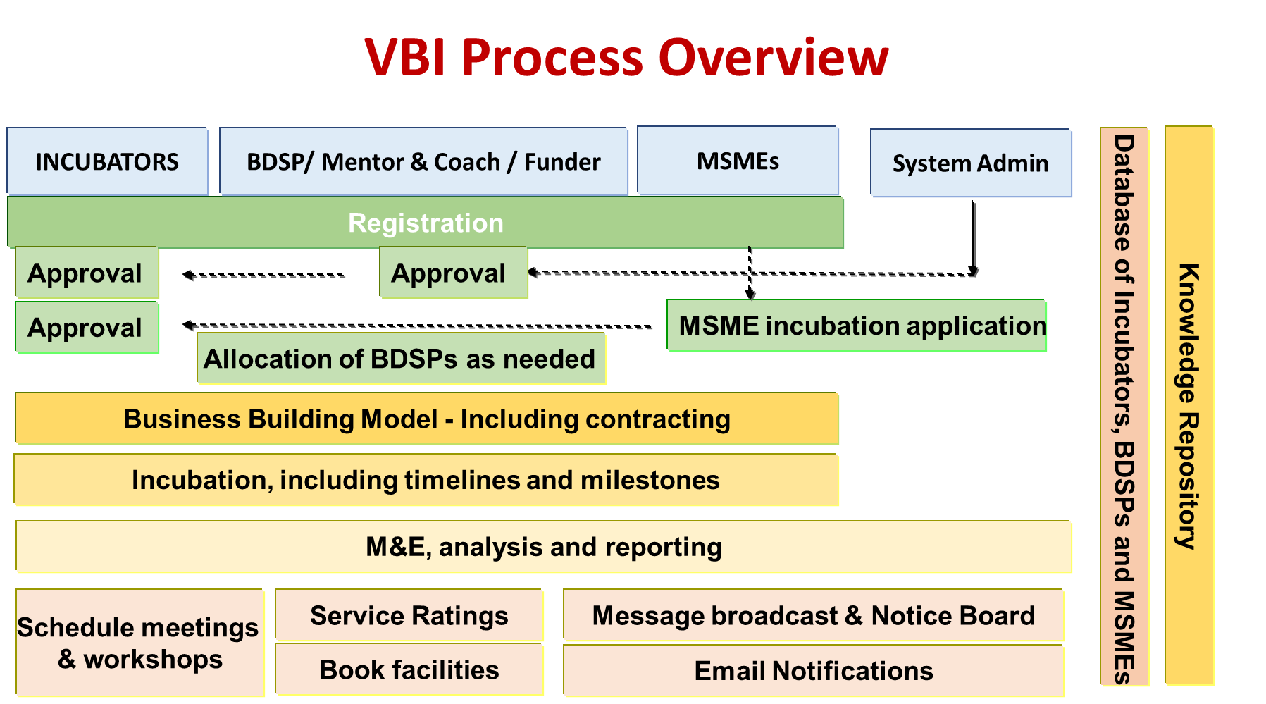

1. **System Actors**

Various individuals and organisations will have access to the BIMP system. There are four main user groups:

* System Administrator
* Business Incubators
* BDSP/Mentor/Coach and
* MSMEs

The following are the main roles. Each user can self-enrol in the system via the web platform but in some cases approval by the System Administrator or the Incubation Manager is required before access is granted:

|  |  |
| --- | --- |
| System Administrator | Responsible for maintaining the BIM Platform and performing access control on the system |
| Incubator Manager(s)  Incubation support staff  Incubation clients | More than one incubator is able to register on the platform. The Incubator Manager is responsible for the control of all the activities relating to his/her incubator.  The System Administrator must approve the registration / application before an incubator can access the platform. |
| Staff reporting to an incubator manager and/or BDSPs allocated to an incubation client and which are required to perform certain functions as allocated by the incubator manager. |
| MSMEs that have contracted with an incubator (clients of an incubation programme or incubatees) that have profiles on the system and have been incorporated into an incubation programme. They may also be identified under the MSME profiles. |
| BSDPs / Mentors / Coaches | BSDPs/Mentors/Coaches and other service providers such as funders, are registered on the system as “service providers” for MSMEs but can also be used as resources by an incubator to provide services to clients.  The System Administrator must approve the registration / application before the BDSP can access the platform. |
| MSMEs and other users | MSMEs and/or other interested parties that have a registered profile can access data such as the **knowledge repository** or **service provider database** but are not automatically registered clients of an incubator and have to apply to join an incubator. |
| Other stakeholders | In some circumstances it may be important for other users such as stakeholders to access the information so that they can have direct access and pull reports or check on performance without having to wait for this information from the programme. In this case the System Administrator can also provide access to them as special users. |

System Administrator

**Graphic representation**

* User Management (Managers, Mentors, Coaches and SMEs)
* System and Progress Administration
* Manage Reports
* Technology (product and services support)

SMEs (Incubatees)

* Use Incubation Applications
* Monitor progress
* Access knowledge base
* Access to training and orientation
* Develop products or services



Manager, Mentors and Coaches Managementgers / Coaches / Mentors

Facilities Managers

* Incubation Management
* Run and manage activities
* Progress and growth analysis
* View reports and alerts
* Facility Management
* Equipment Management
* Generate facilities reports

Other Stakeholders

* Support incubation activities
* Interact with role-players in the incubation



1. **Business Incubator Management System (BIMS)**

The Business Incubator Management System (BIMS) provides a platform for multiple Incubators (as independent entities or within a structured programme) to operate on one system where they have access to all registered MSMEs and BDSPs. The BIMP can be used as a Virtual incubator or in-house system. It tracks and monitors in real time the progress of MSMEs through the 5 phases of business development from ideation to maturity.

The growth path (or support agreement) is based on a structured business building model which is fully adaptable to the specific client needs.

The Platform supports the overall on boarding, administration, progress monitoring and reports on business activities undertaken within the incubation environment and tracks performance based on approved/agreed milestones.

**Incubation Life Cycle**

* 1. **IDENTIFICATION PHASE**
* MSME registers on the BIMP from referrals, networks, outreach programs like workshops, conferences, and /or Business Plan Competitions (BPC)
* MSME can elect to join an Incubator or just stay on the platform to get access to the knowledge repository, Incubator database and/or BDSP database.
* MSME Application for incubation assistance
* Automatic acknowledgement of receipt of application both to the incubator and the MSME
* Application assessed by a Selection Committee happens outside the BIMP
* Approved / Rejected by Incubator Email confirmation is sent to MSME
* Once approved, Classify as required (SME or other)
  1. **INITIATION PHASE**
* Approved applications allocated to Incubation Managers.
* Manager allocates Mentors and Coaches
* SME/Client business analysis and proposed Development Plan
* Plan discussed and agreed with Client
* Project plan formulation with milestones.
* Signing of Contracts
  1. **INCUBATION PHASE**
* Coaching and mentoring commences
  + Business development plan
  + Process and model transfer
* Multiple BDSPs can be linked to one MSME to provide the support required.
* Orientation, skill development, training can be scheduled on the BIMP
* BIMP has a knowledge repository which can be accessed at any time
* Partnerships, networks and linkages are always available to MSMEs
* Development Plan for MSMEs addresses 4 different channels of business development, i.e. Product Development; Marketing/Sales; Financial Management and Operations through six phases of enterprise growth from conception to maturity.
* MSMEs perform tasks and activities as agreed with Mentor, Coach and Incubation Manager and the progress is captured.

1. **Monitoring / Analysis and Evaluation**



* The progress of task completion through the development plan for each MSME is tracked against milestones with completion dates and is approved by the incubator manager or coach.
* Dashboard visibility is available for all activities and can be downloaded to pdf or other formats where applicable.
* Automatic data collection on a number of key performance indicators including number of MSMEs in incubation, MSME demographics including gender distribution, age distribution, district and town or village. Per client MSME status, completion percentages, number of jobs created per period and funds raised for clients is also tracked.
* Incubators, BDSPs and Clients all have access to and can evaluate the performance of the service on a 5 point evaluation platform. This is done on a number of indicators. The individual performance ratings are then aggregated to provide the users with a 5-star rating on the service providers, including the incubators. This allows the MSME users to make an informed decision on the quality of the incubator or MSME which it wishes to engage. It also allows the System Administrator (or owner of the platform) to disengage (remove) non-performing entities from the BIMP.
* The BIMP provides a comprehensive database with all the relevant information of all the MSME, BDSP and Incubators in the eco-system
* System data also provides log-in results and browsers that have been used to access the platform.
* Stakeholders and Funders can also be granted access to the platform to monitor results in real time and not have to wait for the incubator or platform to provide reports.

1. **Compatibility and Modification**

* The platform is completely flexible and can be modified to suite your specific requirements.
* The BIMP is web-based and ready for cloud based operations
* Accessible through internet and has responsive web design technologies incorporated
* Secure, using industry standard security and encryption methods.
* Data validation for and on both client and server side.
* Real-time collection, processing and management of data and information
* Provides Data Integration Modules.
* Open to Integration with other applications and systems.
* Don't Repeat Yourself (DRY) principle applied in coding.
* Search, Create, Read, Update, Delete (SCRUD) implemented in operations.
* Role Based Access Control (RBAC) to authorize system resources allocation to users.
* Compatibility to all the browsers (Mozilla Firefox, internet Explorer, Google Chrome, Opera, Safari).
* Seamlessly Scalable and upgradeable as and when the number of users and content increases.
* Run optimally (page load time below 30 seconds) on a PC connected to a network with minimum bandwidth of 512 kbps.
* Image and other content customization features built in the system to allow standard content sizes (e.g. standard image sizes for easy uploading and processing).
* System allows input of imagery and FAT32 compression for storage and transmission of data.
* Provide user help functionality on major components (e.g. FAQs)
* Provide Contracts Management features for SMMEs